



**VeLog**

**Web Services App**

**Deployment Documentation**

**Contents**

1. **Creating an Azure Configuration**
2. **SQL Configuration on Azure**
   1. **Server & Database**
   2. **Run Script in SQL Server Management Studio**
3. **Creating the Web App on Azure**
4. **Publishing the Visual Studio VeLog Data App on Azure**
5. **Checking Web Service / API’s**
6. **Testing Azure Database**
   1. **Using SQL Server Management Studio**
   2. **Using the Web App in Visual Studio**
7. **Creating an Azure Configuration**

Signup and Login to your Azure account (<https://azure.microsoft.com>).

Access the Azure Portal (<https://portal.azure.com/>).

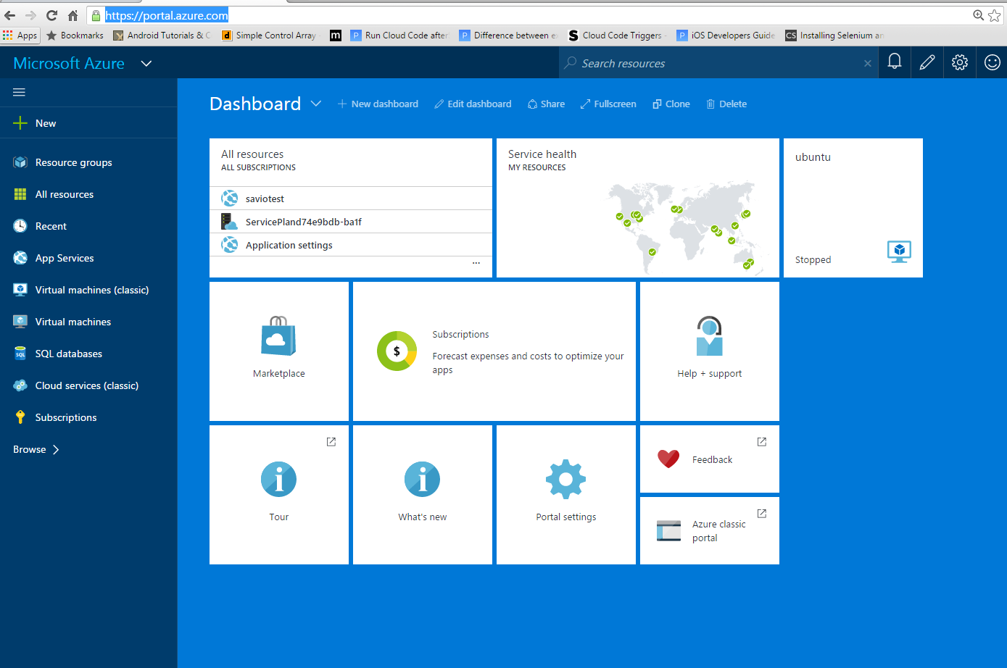

1. **SQL Configuration on Azure**

Create a SQL Server database on Azure.

* 1. **Server & Database**

Click on New --> Data + Storage --> SQL Database.

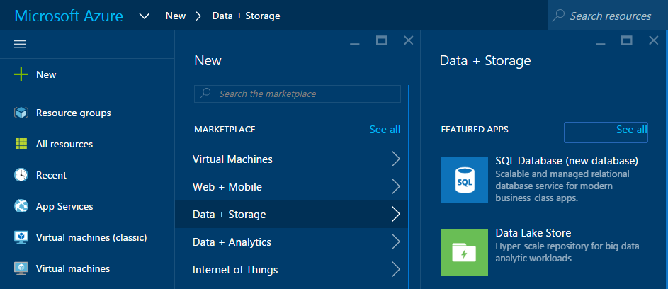

Next you need to setup the settings for SQL database and the server.

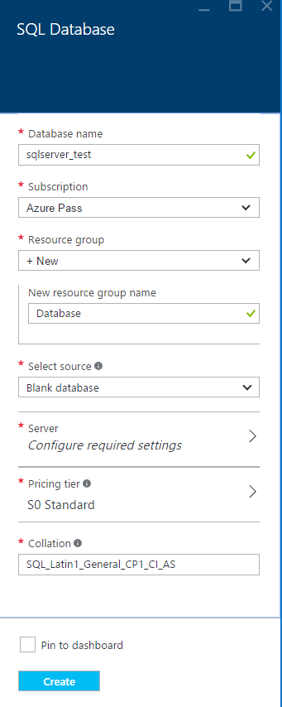 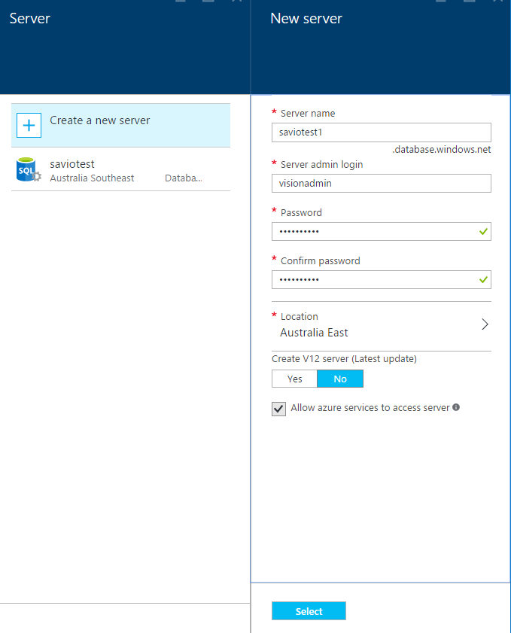

Pricing tier (Select the cheapest so that you do not exceed your credit limit).

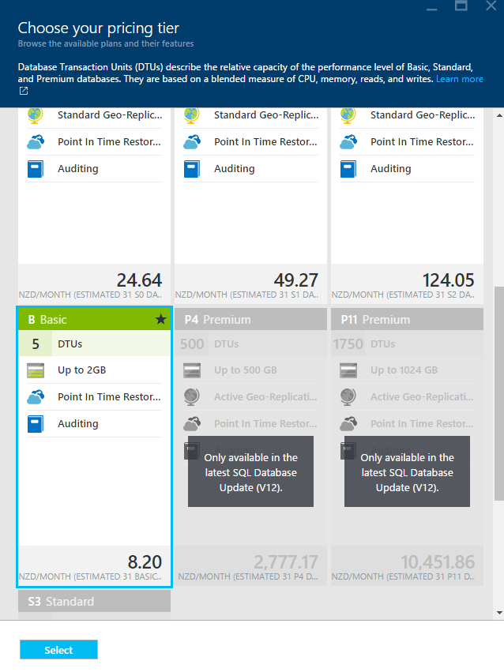

Select and then create your database server.

Under all resources you can see your SQL server.





Click on your SQL server.

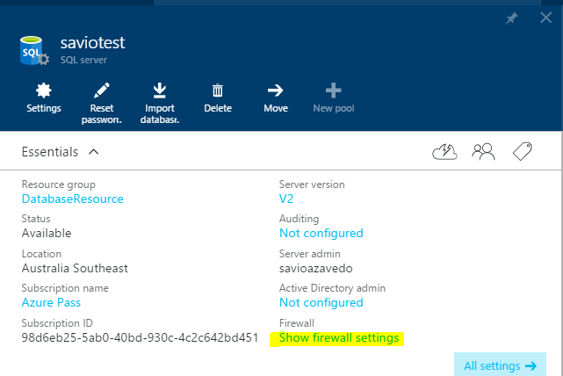

And access your firewall settings (This is important since you only allow computers with these IP addresses to access your server).

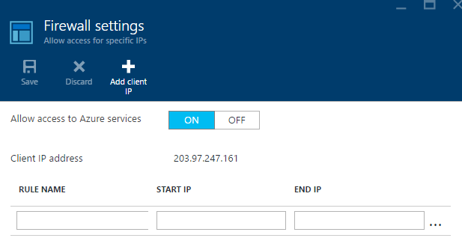

Click on Add client IP to open to add your computer to access the database.

Next click on your database (you will find a server name and connection strings).

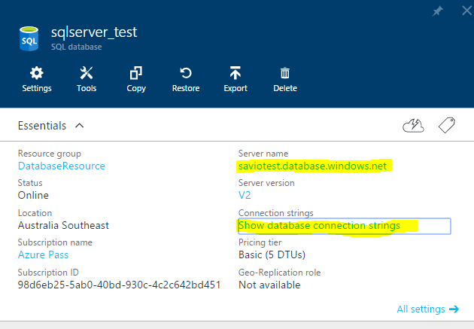

* 1. **Run Script in SQL Server Management Studio**

Go to your SQL Server Management Studio

Enter the server name (created in Azure), login and password and click connect

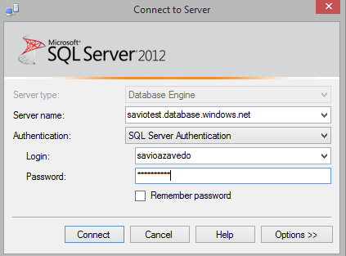

Now under your server you can find your databases.

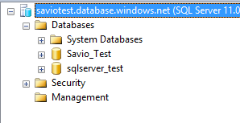

Right-click on your database name -- > New Query.

Create your database tables and records, or copy and paste your Master SQL script.

Execute your query.

|  |
| --- |
|  |
| *image 2a* |

Check you tables/records

|  |
| --- |
|  |
| *image 2b* |

1. **Creating the Web App on Azure**

Login to the Azure portal.

Click New -- > Web + Mobile -- > Web app -- > complete all the required details -- > click create

|  |
| --- |
|  |
| *image 3a* |

1. **Publishing the Visual Studio VeLog Data App**

Open your app in Visual Studio, right-click solution name -- > Publish

|  |
| --- |
|  |
| *image 4f* |

|  |
| --- |
|  |
| *image 4* |
|  |
| *image 4a* |
|  |
| *image 4b* |
|  |
| *image 4c* |
|  |
| *image 4d* |
|  |
| *image 4e* |

1. **Checking Web Service / API’s**

Go to <https://www.getpostman.com/>

|  |
| --- |
|  |
| *image 5a* |

Click on Chrome App, to install Postman in your Chrome Apps (or create a user account and Sign in).

|  |
| --- |
|  |
| *image 5b* |

Select your REST request type (e.g. GET), enter your API’s URI, click Send to check your response

|  |
| --- |
|  |
| *image 5c* |

|  |
| --- |
|  |
| *image 5d* |

1. **Testing Azure Database**
   1. **Using SQL Server Management Studio**

Insert a record into the database using SQL.

Use a Select query to check the record is in the database.

* 1. **Using the Web App in Visual Studio**

Using Visual Studio, debug your Web App and insert a record into the database.

Connect to your Azure database using the SQL Server Object Explorer in Visual Studio.

Check the record is in the database.

|  |
| --- |
|  |
| *image 6a* |